Chapter 1
INTRODUCTION

1.1 BACKGROUND
In today’s fast-paced publishing industry, decision-making depends heavily on accurate, timely, and well-organized data reports. Traditional manual reporting methods are slow, error-prone, and resource-intensive, which creates inefficiencies in tracking sales performance and analyzing business trends.
To address these challenges, the Reporting Web Application is developed as a secure, browser-based platform designed for a leading publication house. The system enables users to generate, manage, and analyze reports efficiently through an intuitive interface. By providing interactive charts, tables, and filtering options, it helps users gain actionable insights from complex datasets.
Modern organizations rely heavily on data to manage their operations and make strategic decisions. Reporting systems play a crucial role in converting raw data into meaningful information that can be easily understood by managers and decision-makers. These systems help in monitoring business performance, identifying trends, and improving overall efficiency.
A reporting system acts as a bridge between raw data and meaningful information. It transforms unorganized data into structured reports that can be easily understood by decision-makers. These reports provide insights into business performance, trends, and patterns, enabling organizations to identify strengths and weaknesses.
Moreover, reporting systems play a crucial role in strategic planning. Managers and executives rely on reports to evaluate past performance and plan future strategies. For example, sales reports help in understanding which products are performing well and which need improvement.
Another important aspect is real-time monitoring. Modern reporting systems allow users to access live data, which helps in quick decision-making. This is especially important in competitive industries where timely decisions can impact business success.
Thus, an efficient reporting system is essential for improving productivity, enhancing decision-making, and achieving business goals.
The evolution of reporting tools has been dramatic over the last two decades. Early systems were predominantly paper-based or relied on standalone desktop applications with limited sharing capabilities. The advent of the internet and cloud computing has fundamentally transformed how organizations approach data reporting. Web-based reporting applications now enable multi-user access, real-time collaboration, and centralized data management—features that were previously difficult or impossible to achieve.
In the context of the publishing industry, where sales cycles are monthly and territorial performance varies significantly across states, the need for granular and comparative reporting is paramount. A single inaccurate report can lead to incorrect inventory decisions, misallocated budgets, and missed sales targets. Automated reporting systems directly reduce this risk by validating data at entry points and presenting it through standardized, reproducible templates
The following are key features enabled by the background requirement for this application:
- Data centralization for easy access and management.
- Dynamic report generation that can adapt to business needs.
- Visual representation of sales growth and performance.

1.2 PROBLEM DEFINITION /STATEMENT
In the publishing industry, timely and accurate reporting is crucial for analyzing sales, monitoring growth, and supporting informed decision-making. However, the existing manual methods of report generation are time-consuming, prone to human error, and lack real-time insights. These processes often require significant effort to collect, process, and present data, leading to delays and inefficiencies in business operations.
Specifically, account executives and sales managers at publication houses are required to compile monthly sales registers, compute profit margins, and compare actual performance against quarterly targets. When performed manually using spreadsheets, this process can take several working days each month. Errors introduced during data consolidation across multiple files frequently go undetected, resulting in reports that misrepresent actual performance.
Furthermore, the absence of a unified platform means that different stakeholders—owners, account managers, and sales development representatives—work from different versions of data, leading to misaligned decisions. The proposed system directly addresses this fragmentation by serving as a single source of truth accessible to all authorized users.

1.3 OBJECTIVES
- To develop a web-based reporting application that efficiently generates detailed and dynamic reports from stored data.
- To centralize the reporting process to minimize manual effort and reduce human errors.
- To optimize backend performance for fast data retrieval and smooth report generation.
- To implement secure role-based authentication so that each user category accesses only the information relevant to their role.
- To provide interactive data visualization through charts and graphs that simplifycomplex business metrics.
- To design an application that is scalable and maintainable for future enhancements including predictive analytics.

1.4 SCOPE OF THE PROJECT
The Reporting Web Application aims to streamline the process of report generation, management, and analysis for businesses, especially in the publishing industry. It provides a centralized and secure platform that enables users to access, view, and analyze data in an organized manner. The application is designed to enhance the efficiency of business reporting by replacing traditional manual methods with an automated, user-friendly web-based system.
The scope of this project includes the development of various modules that allow users to generate dynamic reports, apply filters, and visualize data through interactive charts and graphs. It ensures secure data access using authentication and role-based permissions, preventing unauthorized usage. The system will also include features for tracking sales growth and analyzing business performance over time, offering insights that assist in informed decision-making.
Moreover, the system is designed to be scalable and adaptable to future requirements. As business needs evolve, the application can be enhanced with additional features such as advanced analytics and predictive reporting. The flexibility of the system ensures that it can be integrated with other business applications, thereby creating a unified data ecosystem. This adaptability makes the system a long-term solution for organizations aiming to improve their reporting processes.
The project scope explicitly excludes: inventory management, customer relationship management (CRM) beyond sales data, and payroll processing. These domains, while related, are treated as integration points rather than core features

1.5 APPLICATION
- Business Data Analysis:
It helps management teams generate detailed reports that reveal performance trends, sales growth, and operational efficiency.
- Sales Tracking:
The application allows businesses to monitor sales performance and growth over time. By visualizing data through charts and graphs.
- Secure Data Management:
The web app ensures secure access and storage of sensitive business data through authentication and authorization mechanisms.
- Performance Monitoring:
Managers and team leaders can use the system to track employee or departmental performance through periodic reports.
5. Target vs. Actual Comparison
The system allows sales managers to set monthly or quarterly targets for each state or region and automatically compares them against actual sales figures.
6. Multi-Role Access and Collaboration
By supporting multiple user roles, the platform facilitates seamless collaboration. Each role sees a view tailored to its responsibilities, reducing information overload while ensuring data transparency

Chapter 2
LITERATURE REVIEW

2.1 EXISTING SYSTEM /RELATED WORK

In this system, most organizations rely on manual or semi-automated methods for report generation and data analysis. These reports are often created using tools like Microsoft Excel or Google Sheets, where users manually collect, enter, and analyze data. Such processes are time-consuming, prone to human error, and often lack real-time data synchronization. As a result, decision-makers face delays in accessing accurate information, which affects business performance and responsiveness.
Some organizations use basic web-based dashboards or standalone reporting tools, but these systems often lack essential features like role-based access control, dynamic filtering, and interactive visualization. Moreover, many existing applications do not provide secure centralized access, making data management complex and less efficient. In addition, integration with live databases or automated data fetching is often limited, which restricts real-time analysis.
To overcome these limitations, the proposed Reporting Web Application aims to provide a secure, interactive, and automated solution that simplifies the reporting process
A survey of commonly used business intelligence tools—including Microsoft Power BI, Tableau, and Google Data Studio—reveals that while these platforms offer powerful visualization capabilities, they are prohibitively expensive for small and medium-sized publication houses. The proposed system fills this gap by offering a purpose-built, cost-effective alternative tailored specifically to the workflows of a publication house.
Research by Smith et al. (2021) highlights that organizations using custom web-based reporting tools report a 30–40% reduction in time spent on report preparation compared to those relying on manual spreadsheet-based methods. This finding reinforces the value proposition of the proposed system.

2.2 LIMITATIONS OF EXISTING SYSTEMS

- No Centralized Platform:
Data is often scattered across multiple files or systems, making it difficult to access and manage efficiently.
- Lack of Real-Time Data:
Reports are not updated automatically, leading to outdated or inaccurate information during analysis.
- Low Efficiency and Scalability:
As the data volume grows, manual systems become slow and inefficient, making them unsuitable for large-scale organizations.
- Difficult Data Sharing:
Reports or datasets cannot be easily shared among team members without manual transfer, which leads to communication delays.
- Complex Maintenance:
Maintaining and updating multiple files or report formats requires significant manual effort and technical knowledge.
- Poor Data Security:
Data stored in local systems or shared files is vulnerable to unauthorized access. There are no proper authentication or authorization mechanisms to protect sensitive business information.
- Poor User Experience:
Traditional systems often have complex interfaces that are not user-friendly. Users may require training to operate these systems effectively.
- High Maintenance Effort:
Maintaining multiple files and updating reports manually requires significant time and effort. It also increases the chances of errors during updates.
- Data Inconsistency:
In traditional systems, data is often stored in multiple files or spreadsheets. This leads to inconsistencies where the same data may have different values in different.

2.3 RESEARCH GAP
- Secure API Development in C# Using JWT Authentication:
This study explains how to secure APIs using JSON Web Tokens (JWT) for authentication and authorization. But it does not explore advanced security measures such as anomaly detection, API rate limiting, or AI-driven threat prevention.
- Testing and Debugging C# APIs with Postman and xUnit:
This paper emphasizes techniques for testing and debugging APIs effectively using Postman and xUnit frameworks. However, it lacks focus on continuous integration and delivery (CI/CD) automation, which is essential for large enterprise applications
- Designing RESTful APIs with ASP.NET Web API:
This paper focuses on building RESTful APIs using ASP.NET Web API for efficient data exchange. However, it offers limited discussion on performance optimization techniques like caching, asynchronous streaming, and connection pooling for large-scale applications
- Web-Based Data Visualization for Business Intelligence Systems:
This paper discusses the use of web technologies for creating data visualization dashboards in business intelligence systems. However, it does not address the challenges of real-time data synchronization, scalability, and secure multi-user access, which are crucial for modern reporting application.
- Role Based Access in Multi-Tier Web Applications
Existing literature on RBAC often focuses on enterprise-grade frameworks. There is a gap in lightweight, easily deployable RBAC implementations suitable for SME-scale publishing businesses, which the proposed system addresses through its user_role and user_master table design.

2.4 COMPARATIVE ANALYSIS OF EXISTING SYSTEMS
In order to understand the effectiveness of the proposed Reporting Web Application, it is important to compare it with the existing traditional systems used in organizations. Most existing systems rely heavily on manual processes or basic tools such as spreadsheets (Microsoft Excel or Google Sheets). These tools require manual data entry, manual calculations, and manual report generation, which increases the chances of human errors.
In contrast, the proposed system is fully automated and web-based, which significantly improves efficiency. The system provides real-time data access, which means that reports are always updated with the latest information. This is a major improvement over traditional systems where data updates are delayed.
Another important factor is data security. Existing systems often lack proper authentication and authorization mechanisms, making sensitive data vulnerable. The proposed system uses role-based access control and secure login systems, ensuring that only authorized users can access specific data.
Moreover, traditional systems do not provide proper data visualization tools. The proposed system includes interactive charts, graphs, and dashboards, which help users easily understand complex data.
Thus, the proposed system is more efficient, secure, scalable, and user-friendly compared to existing systems.
In order to understand the effectiveness of the proposed system, it is important to compare it with existing traditional systems. Most existing systems rely heavily on manual processes or basic tools such as spreadsheets. The proposed system is fully automated and web-based, which significantly improves efficiency.

Feature | Manual | Standalone Tools | Proposed System
Real-Time Data | No | Partial | Yes
Role-Based Access | No | Limited | Yes
Interactive Charts | No | Partial | Yes
Centralized DB | No | Partial | Yes
Scalability | Low | Medium | High
Security | Poor | Moderate | High (JWT)
Development Cost | Low | High | Low
Audit Trail | None | Limited | Complete
Export Formats | Manual | Limited | CSV/Excel/PDF

2.5 NEED FOR THE PROPOSED SYSTEM
1. Need for Automation
Manual processes are slow and inefficient. Automation reduces human effort, saves time, and improves productivity. Automated systems can generate reports instantly without manual intervention.
2. Need for Real-Time Reporting
Businesses require real-time insights to respond quickly to market changes. Delayed information can lead to poor decision-making. The proposed system provides real-time data access, enabling quick and accurate decisions.
3. Need for Data Accuracy
Manual systems are prone to errors. Automated systems ensure data accuracy by minimizing human involvement and using validation techniques.
4. Need for Centralized Data Management
In traditional systems, data is scattered across multiple files and systems. A centralized database ensures that all data is stored in one place, making it easier to manage and access.

5. Need for Enhanced Security
With increasing cyber threats, data security is essential. The proposed system uses secure authentication and encryption to protect sensitive data.
6. Need for Scalability
As businesses grow, data volume increases. The system must be able to handle large datasets efficiently. The proposed system is designed to scale with business growth.
7. Need for Better Visualization
Decision-makers require clear insights from data. Visual representations such as charts and dashboards help in understanding trends and pattern at a glance.
8. Need for an Audit Trail
Compliance and governance requirements demand that every data modification be traceable. The proposed system records complete metadata for every record.

Chapter 3
SYSTEM ANALYSIS

3.1 REQUIREMENT ANALYSIS
The Reporting Web Application requires a well-balanced combination of hardware, software, and functional components to ensure efficient data processing, secure access, scalability, and real-time reporting for users and administrators..
Hardware Requirements:
- Processor: Intel Core i3/i5 Or Equivalent (4 Cores Minimum)
- Ram: 8 Gb (16 Gb Recommended)
- Storage: Browser Based Application (Storage not required)
- GPU : Optional, For Multimedia And Analytics Processing

Software Requirements:
- Frontend: ReactJS, HTML ,CSS, JavaScript
- Backend: C# and JQuery
- Database: MySql

Functional Requirements:
- To generate detailed and dynamic reports based on stored business data.
- To visualize sales and performance data through interactive charts and graphs.
- To manage user accounts and maintain secure access logs.
- To provide user authentication and role-based access control for admin and authorized users.
• To allow filtering of reports by month, year, state, and
- To enable the Admin to register new users and assign roles.
- To provide a password recovery mechanism foe registered users.

Non-Functional Requirements:
- The interface should be simple, intuitive, and user-friendly.
- The system should easily handle an increasing number of users and data records.
- The system should respond quickly even with large data volumes.
- The application should function smoothly on all major browsers.
- The Codebase should follow clean architecture principles.

3.2 SYSTEM CONSTRAINTS
The development of the Reporting Web Application is subject to certain constraints. These constraints must be considered to ensure successful implementation.
One of the major constraints is technical limitation. The system must be compatible with existing hardware and software environments. It should also work efficiently on different browsers and devices.
Another constraint is time. The project must be completed within a specified timeframe, which requires proper planning and resource management.
Cost is also an important factor. The system should be developed using cost-effective technologies to minimize expenses.
Finally, security constraints must be considered. The system must protect sensitive data and prevent unauthorized access.
Additionally, the system is constrained by the existing IT infrastructure of the publication house. The MySQL database must be hosted on a server accessible within the organization's network, and the ASP.NET backend requires a server with the .NET runtime installed.

3.3 FEASIBILITY STUDY
A feasibility study is conducted to determine the practicality, efficiency, and success potential of developing the Reporting Web Application. It evaluates the technical, operational, economic, and legal aspects of the system to ensure that the project can be implemented effectively within the given constraints.
- TECHNICAL FEASIBILITY:
The proposed Reporting Web App is technically feasible as it utilizes modern and stable technologies. The frontend is developed using React.js, HTML, CSS, and JavaScript, which ensures a responsive, dynamic, and user-friendly interface. The backend uses C# for server-side logic and jQuery for enhanced interactivity, providing smooth communication between the client and the server.

- ECONOMIC FEASIBILITY:
The economic feasibility of the project is high because it relies primarily on open-source and cost-effective technologies such as React.js and MySQL. The development cost is limited to domain registration, hosting services, and minimal maintenance charges, which are estimated to be around ₹10,000–₹15,000.
Over time, the system will reduce operational costs by automating report generation, minimizing manpower needs, and improving overall productivity.
- OPERATIONAL FEASIBILITY:

The system is operationally feasible because it replaces manual and error-prone reporting processes with an automated, centralized web platform. Users such as administrators and managers can easily generate, view, and analyze reports without extensive technical knowledge.
4. LEGAL FEASIBILITY:
All technologies used in the project are either open-source or commercially licensed. No third-party data or intellectual property is incorporated without appropriate authorization. Access is controlled through role-based permissions, ensuring compliance with data privacy best practices.

3.4 RISK ANALYSIS
Risk analysis is an important part of system development. It helps in identifying potential risks and planning strategies to mitigate them.
One possible risk is system failure due to technical issues. This can be addressed by implementing proper testing and backup mechanisms.
Another risk is data loss, which can occur due to system crashes or unauthorized access. This can be prevented by using secure databases and regular backups.
User resistance is also a potential risk. Users may be hesitant to adopt a new system. This can be addressed by providing proper training and support.

Risk | Likelihood | Impact | Mitigation Strategy
System Failure | Low | High | Regular backups; automated failover testing
Data Loss | Low | Critical | Daily DB backups; secure cloud storage
Unauthorized Access | Medium | High | JWT auth; RBAC; session timeouts
User Resistance | Medium | Medium | Training; intuitive UI; feedback loops
Scope Creep | Medium | Medium | Defined requirements; change management`
Performance  Degradation | Low | Medium | Indexed queries; pagination; load testing

3.5 PROBLEM IDENTIFICATION AND PROPOSED SOLUTION
In many organizations, report generation and data analysis are still performed manually using spreadsheets or basic tools. This traditional approach leads to several challenges such as time-consuming processes, frequent human errors, poor data visualization, and lack of real-time information. Moreover, without a centralized and secure platform, managing, sharing, and updating reports becomes inefficient, which affects overall productivity and decision-making accuracy..
To overcome these challenges, the proposed Reporting Web Application provides a centralized, automated, and secure system for generating and managing business reports. Developed using React.js, HTML, CSS, and JavaScript for the frontend and C# with MySQL for the backend, the application enables users to generate dynamic reports, visualize data through interactive charts, and access real-time insights. With role-based authentication and a user-friendly interface, the system ensures data security, reduces manual effort, and enhances decision-making efficiency within the organization.
1. PROPOSED SOLUTION
The aims to overcome the limitations of traditional manual reporting systems by introducing an automated, secure, and centralized web-based platform. It is designed to streamline report generation, enhance data visualization, and improve decision-making efficiency for organizations..
- It uses React.js, HTML, CSS, and JavaScript for building a dynamic and user-friendly interface, ensuring smooth interaction and responsive design.
- The backend is developed in C# with jQuery, which handles server-side operations, logic execution, and communication with the database effectively.
- MySQL is used as the database to securely store and manage all report-related information, ensuring data consistency and integrity.
- The system provides a centralized reporting dashboard where all business data can be accessed, analyzed, and managed efficiently..
- The system integrates interactive charts and graphs, allowing visualize complex data trends easily and make better business decisions..
- Export functionality (CSV, Excel, PDF) enabling stakeholders to share and archive reports.

Chapter 4
SYSTEM DESIGN

4.1 SYSTEM ARCHITECTURE

AVG Transact Value
Total Sales Value
Product Quantity
Sales Register
Target VS Actual
Monthly Sales
Reports
Graphs
KPIs
account executive
Sales Operations Manager
Owner

Registration Page

Admin

Sales Booking

Profit Margin

Monthly Sales

Dashboard

Owner

account manager

Login Page

sales development representative

Role

1. Level 0 DFD
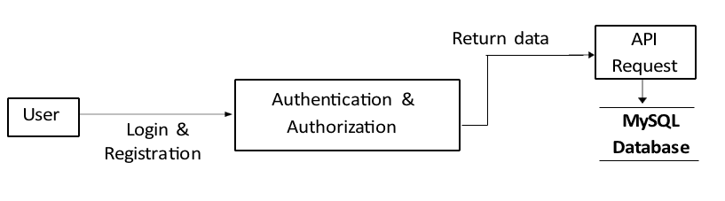

2. Level 1 DFD

Download Reports

Owner or Admin

Register New User

Database

Recover Password

Authorize User

Specific Month Data

API

4.3 UML Diagrams
1. ACTIVITY DIAGRAM
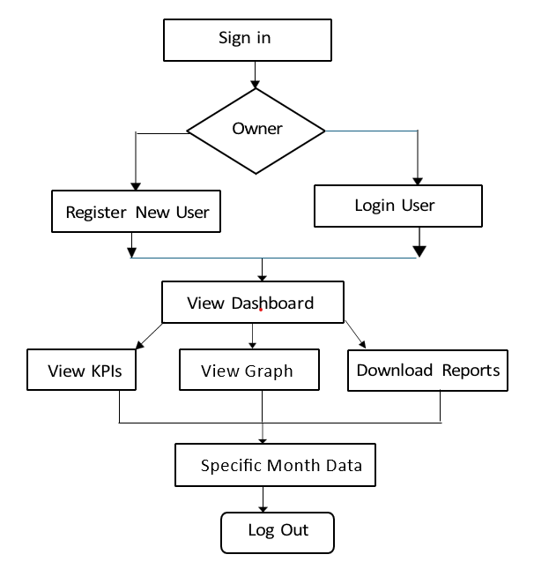

4.3 Database Design

user_role
ID | Numeric
Name | String
CreatedBy | Numeric
CreatedOn | DateTime
ModifiedBy | Numeric
ModifiedOn | DateTime
IsActive | Boolean

user_master
ID | Numeric
Name | String
Email | String
Phone | Numeric
Password | String
UserRoleID | Numeric
CreatedBy | Numeric
CreatedOn | DateTime
ModifiedBy | Numeric
ModifiedOn | DateTime
IsActive | Boolean

state_master
ID | Numeric
Name | String
CreatedBy | Numeric
CreatedOn | DateTime
ModifiedBy | Numeric
ModifiedOn | DateTime
IsActive | Boolean

product_master
ID | Numeric
Code | String
Name | String
UnitPrice | Numeric
CreatedBy | Numeric
CreatedOn | DateTime
ModifiedBy | Numeric
ModifiedOn | DateTime
IsActive | Boolean

customer_master
ID | Numeric
Name | String
CreatedBy | Numeric
CreatedOn | DateTime
ModifiedBy | Numeric
ModifiedOn | DateTime
IsActive | Boolean

sales_target
ID | Numeric
StateID | Numeric
MonthName | String
Year | Numeric
TargetAmount | Numeric
CreatedBy | Numeric
CreatedOn | DateTime
ModifiedBy | Numeric
ModifiedOn | DateTime
IsActive | Boolean

sales_transaction_details
ID | Numeric
ProductId | Numeric
SalesID | Numeric
UnitPrice | Numeric
Quantity | Numeric
Amount | Numeric
CreatedBy | Numeric
CreatedOn | DateTime
ModifiedBy | Numeric
ModifiedOn | DateTime
IsActive | Boolean

Sales_transaction
ID | Numeric
SalesDate | Date
CustomerID | Numeric
StateID | Numeric
CreatedBy | Numeric
CreatedOn | DateTime
ModifiedBy | Numeric
ModifiedOn | DateTime
IsActive | Boolean

production_cost
ID | Numeric
ProductId | Numeric
Cost | Numeric
Month | Numeric
Year | Numeric
CreatedBy | Numeric
CreatedOn | DateTime
ModifiedBy | Numeric
ModifiedOn | DateTime
IsActive | Boolean

Chapter 5

IMPLEMENTATION DESIGN

5.1 SOFTWARE & HARDWARE REQUIREMENTS

Software components | Description
Operating system | Windows 11, MAC OS
Frontend framework | React.js with bootstrap for building responsive and interactive user interface
Back-end technologies | C# and JQuery for handling server-side logic and API integration
Database | MySQL for storing users, learning paths, modules, and progress data
Development environment | Visual Studio 2022

1. Operating System (Windows 11, macOS)
The project is developed and tested on modern operating systems such as Windows 11 and macOS. These operating systems provide a stable and secure environment for software development and execution. Windows 11 offers strong compatibility with development tools like Visual Studio 2022, along with enhanced security features, multitasking capabilities, and a user-friendly interface. macOS, on the other hand, is widely preferred for its Unix-based architecture, stability, and performance efficiency. It provides a robust terminal environment and seamless support for web development technologies. Using both platforms ensures cross-platform compatibility and improves the flexibility of the application.

2. Frontend Framework (React.js with Bootstrap)
The frontend of the application is developed using React.js along with Bootstrap. React.js is a popular JavaScript library used for building dynamic and interactive user interfaces, especially for single-page applications (SPAs). It follows a component-based architecture, allowing developers to create reusable UI components, improving code maintainability and scalability.
Bootstrap is integrated to provide a responsive design framework. It includes pre-designed CSS classes and components such as buttons, forms, navigation bars, and grids. This ensures that the application is mobile-friendly and adapts to different screen sizes.
The combination of React.js and Bootstrap enhances user experience by providing fast rendering, responsive layouts, and visually appealing interfaces.

3. Back-end Technologies (C# and jQuery)
The backend of the application is developed using C# along with jQuery for handling client-side interactions. C# is a powerful, object-oriented programming language used within the .NET framework. It is responsible for handling server-side logic, business rules, and data processing. It also manages API creation and integration, ensuring secure communication between frontend and database. jQuery is used to simplify client-side scripting, including DOM manipulation, event handling, and AJAX calls. It helps in creating dynamic web pages by enabling asynchronous communication with the server without reloading the page.
Together, these technologies ensure efficient processing, faster communication, and a smooth user experience.

4. Database (MySQL)
MySQL is used as the primary database management system for storing and managing application data. It is an open-source relational database that supports structured data storage using tables, rows, and columns. In this project, MySQL is used to store user information, learning paths, modules, and progress tracking data. It ensures data integrity, consistency, and security through constraints and relationships. MySQL also supports efficient querying using SQL (Structured Query Language), enabling fast data retrieval and manipulation. Its scalability allows the system to handle increasing amounts of data as the application grows.

5. Development Environment (Visual Studio 2022)
Visual Studio 2022 is used as the primary Integrated Development Environment (IDE) for this project. It provides a comprehensive set of tools for coding, debugging, testing, and deploying applications. The IDE supports multiple programming languages, including C#, and offers features like IntelliSense (code suggestions), error detection, and built-in debugging tools.
It also integrates well with version control systems and supports extensions that enhance productivity. Visual Studio 2022 simplifies the development process and helps in maintaining high code quality.

5.2 TOOLS & TECHNOLOGY
1.Front-End Technologies

Tool/Language | Purpose/Role in Project
HTML5 (Hypertext  Markup Language) | Used to design the structure of all web pages including login, dashboard, and KPI cards. Defines layout and content placement.
JavaScript (ES6+) | Adds interactivity, handles dynamic data rendering, and ensures a smooth and responsive user experience.
React.js with Bootstrap | Builds modular, fast-loading user interfaces with reusable components and responsive layouts.

1. HTML5 (Hypertext Markup Language)
HTML5 is used to design and structure all the web pages of the application, including the login page, dashboard, and KPI (Key Performance Indicator) cards. It provides the fundamental building blocks for creating web content by defining elements such as headings, paragraphs, forms, tables, and images.With HTML5, semantic elements like <header>, <footer>, <section>, and <article> are used to improve readability and accessibility. This helps search engines and browsers better understand the content structure.
Additionally, HTML5 supports multimedia elements like audio and video without requiring external plugins, making the application more modern and efficient.

2. JavaScript (ES6+)
JavaScript is used to add interactivity and dynamic behavior to the web application. It enables features such as form validation, real-time updates, event handling, and dynamic content rendering. The ES6+ version of JavaScript introduces advanced features like arrow functions, classes, modules, template literals, and promises, which improve code readability and performance. JavaScript also plays a key role in handling asynchronous operations through AJAX and APIs, allowing data to be fetched and updated without reloading the entire page. This results in a smoother and faster user experience.

3. React.js with Bootstrap
React.js is a powerful JavaScript library used for building fast and scalable user interfaces. It follows a component-based architecture, where the UI is divided into reusable components. This approach improves code maintainability, reduces redundancy, and speeds up development.
React uses a virtual DOM (Document Object Model), which enhances performance by updating only the necessary parts of the web page instead of reloading the entire interface.
Bootstrap is integrated with React to design responsive and visually appealing layouts. It provides a grid system, pre-built components, and utility classes that ensure the application works seamlessly across different devices such as desktops, tablets, and smartphones.
The combination of React.js and Bootstrap results in a modern, responsive, and high-performance user interface.

- Back-End Technologies

Back-End Technology | Description
ASP.net | ASP.NET Core Web API is a high-performance, cross-platform framework used to build secure and scalable RESTful services. It offers built-in dependency injection and flexible middleware, making backend development clean and efficient.
WEB API | A Web API allows different software applications to communicate with each other over the internet using standard protocols. It enables data exchange between client and server, supporting integration across web, mobile, and external systems.
Swagger | Swagger is a tool that automatically generates interactive API documentation for Web APIs. It allows developers to test API endpoints directly in the browser, making development and debugging easier.

1. ASP.NET (ASP.NET Core Web API)
ASP.NET Core Web API is a high-performance, open-source, and cross-platform framework used to build modern web applications and RESTful services. It is developed by Microsoft and is widely used for enterprise-level applications. This framework allows developers to create scalable and secure backend systems that can run on multiple platforms such as Windows, Linux, and macOS. It includes built-in features like dependency injection, middleware support, and routing, which help in organizing code efficiently and improving maintainability.
ASP.NET Core also provides strong security mechanisms such as authentication and authorization, protecting the application from unauthorized access. Its high performance and flexibility make it suitable for handling large-scale applications with multiple users.
2. Web API
A Web API (Application Programming Interface) acts as a bridge between different software applications, enabling them to communicate with each other over the internet using standard HTTP protocols. In this project, the Web API is responsible for exchanging data between the client (frontend) and the server (backend). It processes user requests, performs necessary operations, and sends responses back to the client in formats like JSON or XML.
Web APIs support CRUD operations (Create, Read, Update, Delete), which are essential for managing application data such as users, learning paths, and progress tracking.
They also enable integration with external systems, making the application more flexible and extendable. By separating frontend and backend logic, Web APIs improve scalability and simplify development.
3. Swagger
Swagger is a powerful tool used for designing, documenting, and testing Web APIs. It automatically generates interactive API documentation based on the backend code.
With Swagger, developers can view all available API endpoints, understand request and response formats, and test APIs directly from the browser without using external tools. This significantly simplifies debugging and development. Swagger also improves collaboration among developers by providing a clear and standardized interface for API communication. It ensures that APIs are well-documented, easy to understand, and easier to maintain over time.

- Database & Development Environment

Development & Integration Tool | Description
MySQL Workbench | MySQL Workbench is a visual tool for designing, managing, and querying MySQL databases. It provides an easy-to-use interface for creating tables, running SQL queries, and managing database connections.
Visual Studio 2022 | Visual Studio 2022 is an integrated development environment used to build, debug, and deploy applications. It provides powerful tools, IntelliSense, and a user-friendly interface to support coding across multiple languages and platforms.

1. MySQL Workbench
MySQL Workbench is a powerful visual tool used for designing, developing, and managing MySQL databases. It provides an intuitive graphical user interface that simplifies complex database operations. With MySQL Workbench, developers can create and modify database schemas, tables, relationships, and constraints without writing extensive SQL code manually. It also allows users to execute SQL queries, view results, and optimize database performance. The tool includes features like data modelling, database design (ER diagrams), and server configuration, which help in maintaining a well-structured and efficient database system. Additionally, it supports database migration and backup, ensuring data safety and easy recovery. Overall, MySQL Workbench enhances productivity and makes database management more organized and efficient.
2. Visual Studio 2022
Visual Studio 2022 is a comprehensive Integrated Development Environment (IDE) developed by Microsoft. It is widely used for building, testing, and deploying modern applications. Visual Studio 2022 provides a rich set of features such as IntelliSense (code auto-completion), debugging tools, error detection, and performance analysis. These features help developers write clean and efficient code while reducing development time. It supports multiple programming languages including C#, JavaScript, and more, making it suitable for full-stack development. The IDE also integrates seamlessly with version control systems, allowing teams to collaborate effectively. Furthermore, Visual Studio 2022 includes tools for building web APIs, managing databases, and deploying applications to cloud platforms. Its user-friendly interface and powerful capabilities make it an essential tool for modern software development.

5.3 SCREENSHOTS AND WORKING MODULES
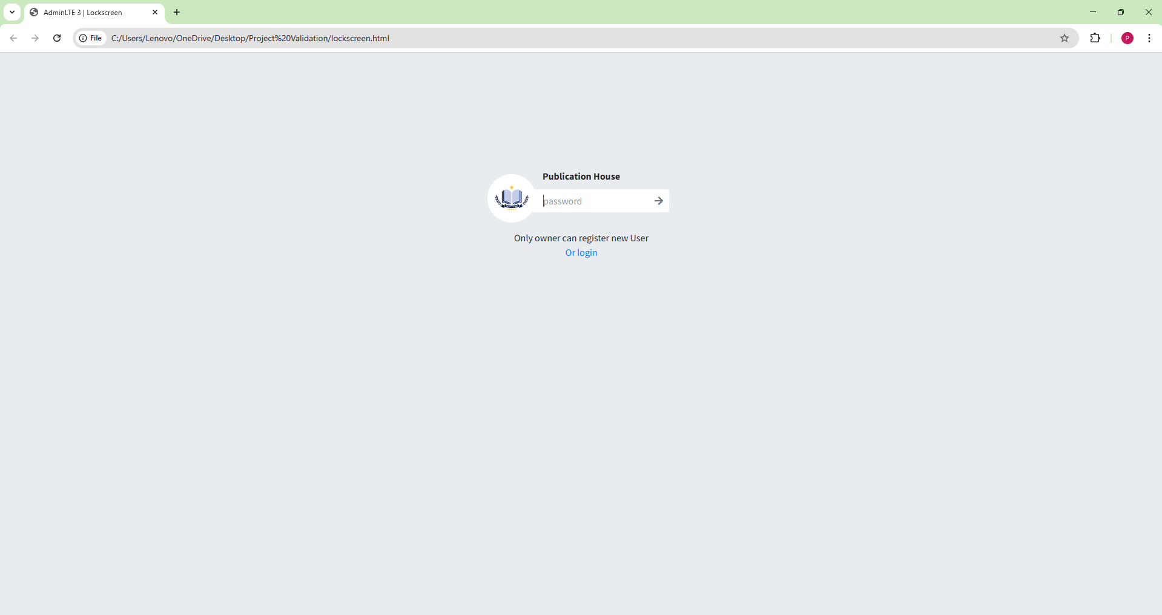
Fig. Admin / Owner Login Page

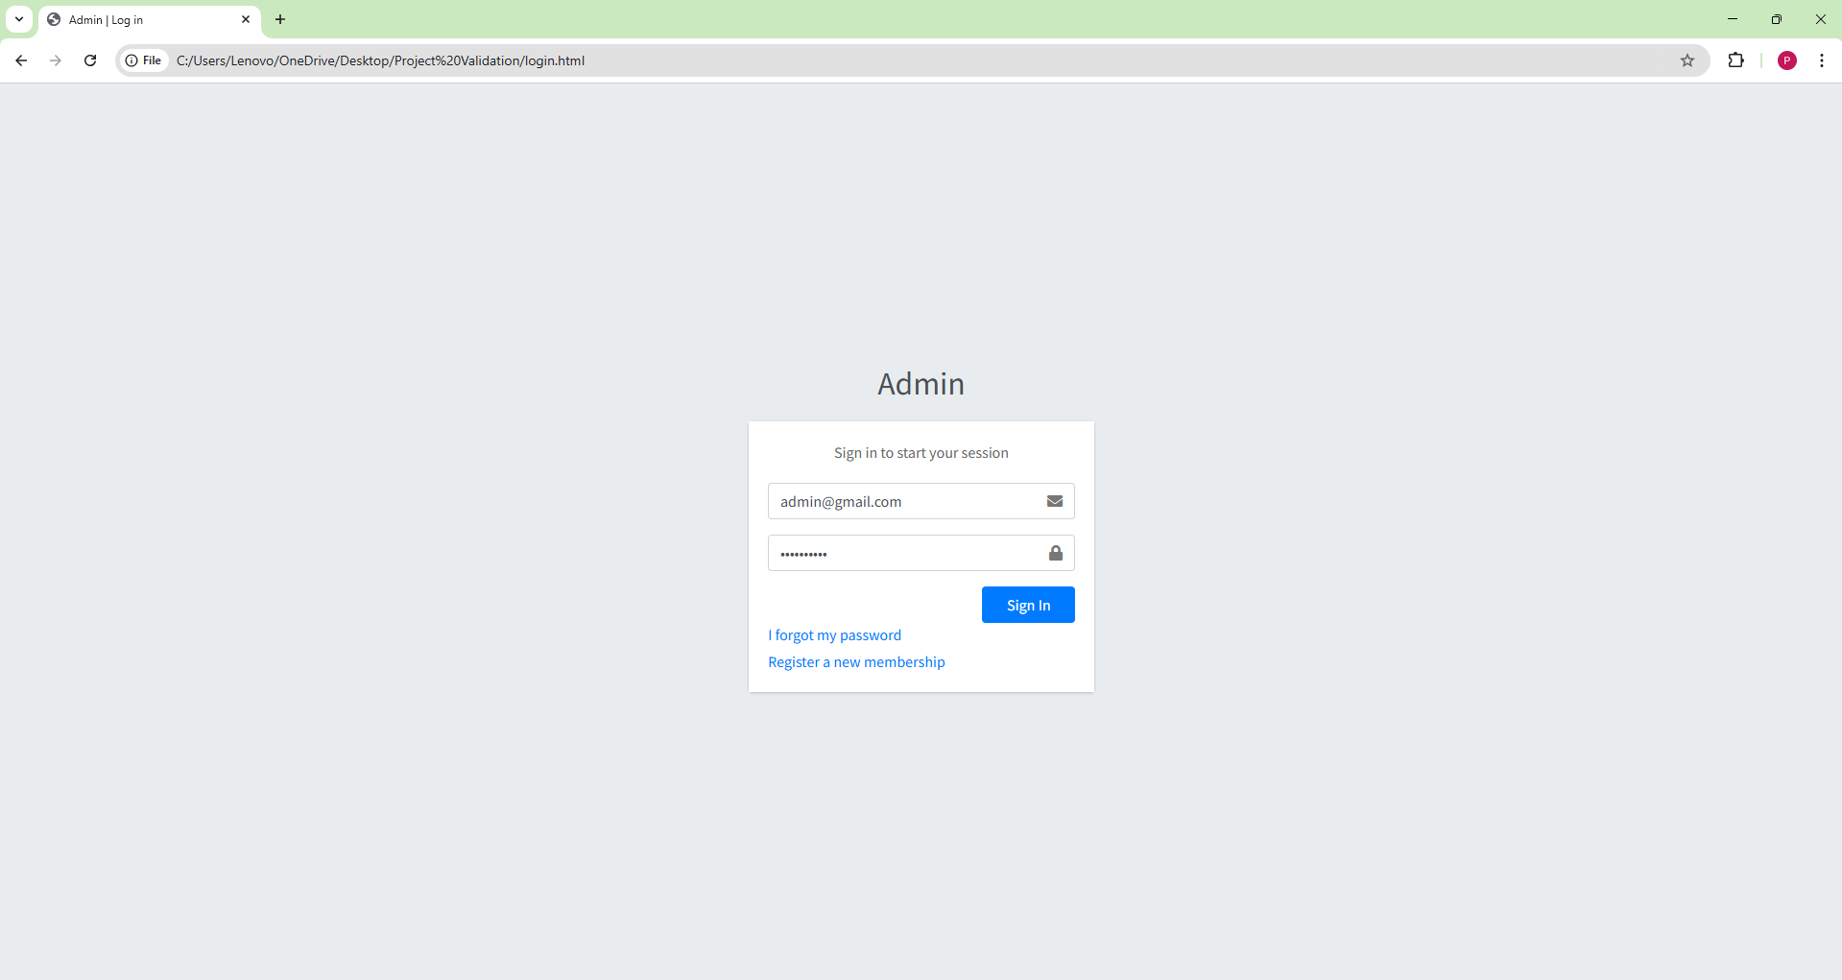
Fig. User Login
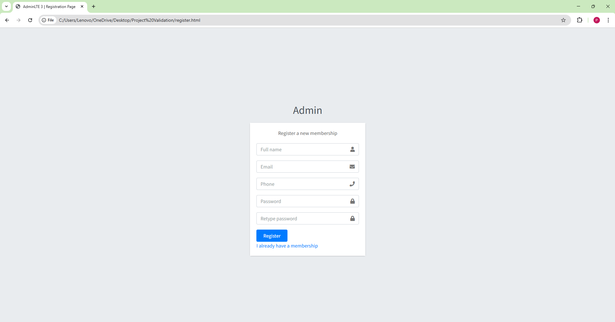
Fig. User Sign Up

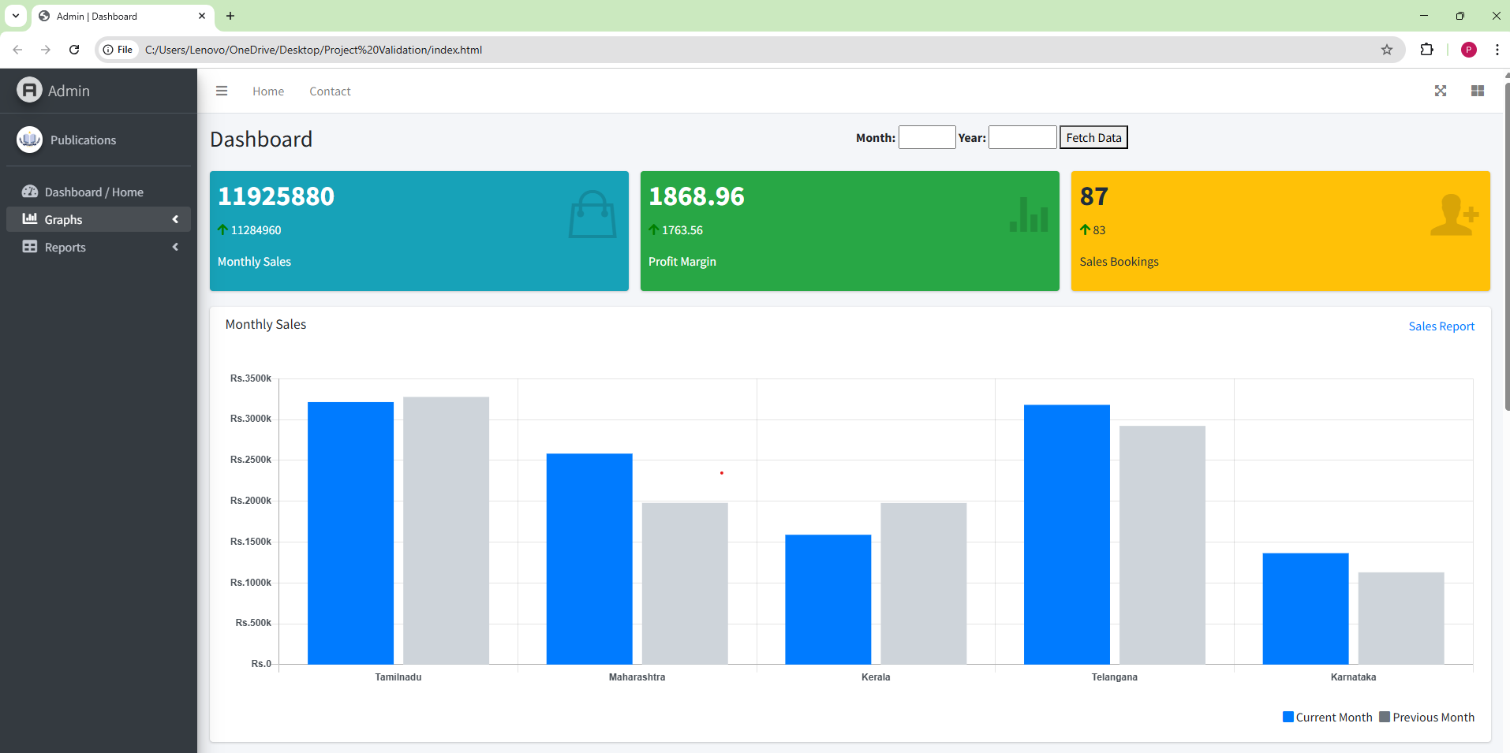
Fig. Main Dashboard

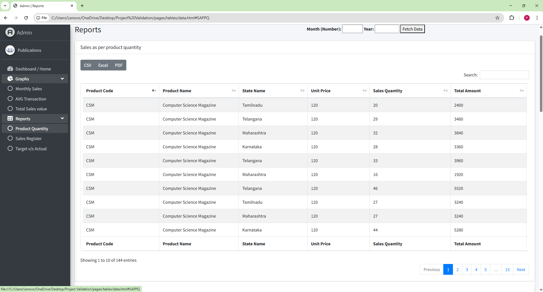
Fig. Reports

Chapter 6

REFERENCES

REFERENCES
- React Documentation, “A JavaScript library for building user interfaces,”
Available at: https://react.dev

- MDN Web Docs, “HTML, CSS, and JavaScript Web Standards and Guides,”
Available at: https://developer.mozilla.org

- jQuery Documentation, “A Fast and Feature-rich JavaScript Library,”
Available at: https://api.jquery.com

- ASP.NET Core Documentation, “Modern Web Development Framework for .NET,” Microsoft,
Available at: https://learn.microsoft.com/aspnet/core

- C# Programming Guide, “Language and Runtime Features,” Microsoft,
Available at: https://learn.microsoft.com/dotnet/csharp

- MySQL Documentation, “Relational Database Management System,”
Available at: https://dev.mysql.com/doc

- MySQL Workbench User Guide, “Database Design and Administration Tool,”
Available at: https://dev.mysql.com/doc/workbench/en

- Bootstrap Documentation (optional if used), “CSS Framework for Responsive UI Design,”
Available at: https://getbootstrap.com

- Visual Studio 2022 Documentation, “Integrated Development Environment for .NET Applications,” Microsoft,
Available at: https://learn.microsoft.com/visualstudio

- W3Schools, “Web Development Tutorials and Examples,”
Available at: https://www.w3schools.com

- Coursera, “Online Learning Platform for Programming and Web Development Courses,”
Available at: https://www.coursera.org

- Udemy, “Online Courses Platform for Technology and Software Development,”
Available at: https://www.udemy.com

Chapter 7

RESEARCH PAPERS & CERTIFICATES

